 

Blended Learning Instructions For CPR/AED/First Aid

This document provides detailed instructions for completing your CPR/AED/First Aid certification. It’s important that you follow the steps below to avoid delays in your certification or re-certification.

# STEP I – COMPLETE THE RED CROSS COURSE ONLINE

* Red Cross provides an interactive online training through their site (link below).
* First-time users must create a log-in. You can use either your personal or your Easterseals email address. For recertifications, the system allows you to reset your password if you forget your credentials.
* Please allow approximately 2- 2 ½ hours to complete the course.
* 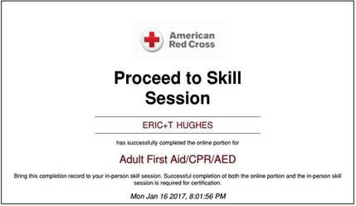Upon completion, you should either print the certificate or have available on your cell phone. The certificate must be presented to the Trainers prior to the in-person session.

# This certificate must be submitted to [awccompliance@nj.easterseals.com](mailto:awccompliance@nj.easterseals.com) with the subject heading "BLENDED LEARNING CERTIFICATE" no later than 24 hours prior to the classroom

*To access the Red Cross online training go to:* [***https://www.redcrosslearning.com/course/02b6b8e0-c611-11e6-81f6-***](https://www.redcrosslearning.com/course/02b6b8e0-c611-11e6-81f6-a5a76b229f34)[***a5a76b229f34***](https://www.redcrosslearning.com/course/02b6b8e0-c611-11e6-81f6-a5a76b229f34)

# IMPORTANT INFORMATION FOR YOUR ONLINE SESSION

* You MUST use either Chrome, Firefox or Microsoft Edge as your browser for this training.

# (Internet Explorer is no longer compatible)

* You may leave the training session ONLY in between **"missions"** (the term used in this training for modules). To return to the training use the same link above and use the login credentials you created.
* If you exit in the middle of a mission, your work will not be saved.
* If you fail a mission, you will be able to redo it until you pass it.

# STEP II – IN-PERSON CLASSROOM SKILLS PORTION

Please contact the Agency with Choice customer service team to schedule your In Person classroom training.

**Their contact information is:** [**awccustomerservice@nj.easterseals.com**](mailto:awccustomerservice@nj.easterseals.com) **or call 1-800-471-3086.**

* During this session, you will be asked to demonstrate the skills you’ve learned during the online portion.
* This should take approximately one (1) hour of classroom time.
* Within 24-48 hours of your classroom session, you will receive a link via email from the Red Cross, to obtain your OFFICIAL certificate. (a wallet card can be also be printed or requested via the Red Cross site [(www.redcross.org)](http://www.redcross.org/)
* The Easterseals trainer will send your certification of completion to [awccompliance@nj.easterseals.com](mailto:awccompliance@nj.easterseals.com) for confirmation.

***\*\*PLEASE READ** - IMPORTANT CERTIFICATION INFORMATION***

* To be certified in CPR/FA, you must pass both Step I and Step II.
* If you are unable to attend the in-person session, please email [awccompliance@nj.easterseals.com](mailto:awccompliance@nj.easterseals.com)
* If you are not certified by your CPR/First Aid expiration date, you will be suspended until you achieve certification and may face additional disciplinary action.
* You MUST complete Step I before you are eligible to complete Step II. If you have not presented the online certificate of completion, you WILL NOT be unable to continue with the classroom training.