
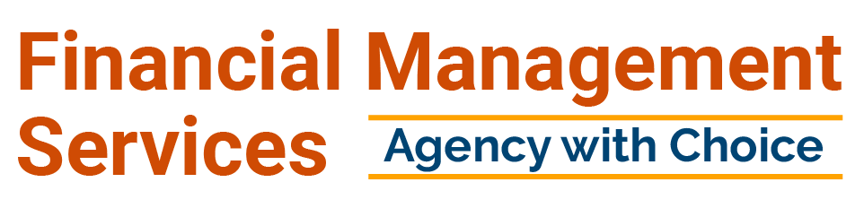
UNDERSTANDING AGENCY WITH CHOICE

August 2024

What is Financial Management Services with the Agency with Choice program
Financial Management Services is the fiscal intermediary assisting with self- directed supports

- Is an organization that assists you to implementing your Individual Support Plan (ISP) and managing financial accountability and employer responsibilities.



- Some functions we offer are processing vendor and self-directed employee payments, handling tax requirements, labor law filings, and much more. In the AwC model, Financial Management Services is the employer, and you are a co-employer.

What is Self-Direction?
Self-Directed Services/Self-Direction is an approach to delivering home and community-based services (HCBS) offering
increased choice and authority over how and from whom an individual receives their waiver services. The self-directed service delivery model is an alternative to more traditional provider-managed services. Self- direction provides an opportunity for participants to manage the organization of the supports and services they elect to receive, supported by their Support Coordinator through the person- centered planning process.



Role of Financial Management Services in AwC
  - Ensure self-directed employees (SDEs) complete and submit background checks and drug testing

  - Ensure SDEs complete all applicable DDD-mandated trainings
within their required timeframes

  - Issue payments to SDEs hired by the individual/authorized representative

  - Issue payments to community vendors that have provided prior authorized services to the individual

  - Ensure appropriate service documentation is submitted by the
SDE and, when applicable, the vendor

  - Ensure services and service documentation align with the Individualized Service Plan (ISP)

Dually Enrolled
No Problem!

Financial Management Services: Agency with Choice

Supports are paid out of your budget
Rate/Hours are determined by individuals and families, and discussed with the support coordinator Referrals are done through I-record and can be sent directly in as a backup
Co-employer Model

PPP- Personal Preference Program
Not funded through the DDD budget. Funded through medical insurance
Hours and rate decided by PCA
Referral and intake done with NCM




Once Agency with Choice receives the FI referral the Onboarding process is initiated
Warm Welcome Webinar Invites are sent to the Managing Employer (ME)


Each family Enrolled into our program will be assigned to an Enrollment Specialist to fully support them throughout the process
Enrollment

SC and AWC specialist should discuss Vendor transfer etc. prior to billable rate and draft submission.

Intake call within 24/48
hours of referral receipt

SC to review the budget/hours/rate/PMPM impact on Individualized service plan early in
the process. This is to ensure families are aware of budget sustainability and minimize delay for final plan of care submission.


Self Directed Employee (SDE) Onboarding Process Flow

SDE New Hire Request SDE Onboarding Screenings Onboarding Completion
Referral / Application Request received by AwC

Initiate Onboarding
Completion of compliance screenings

SDE cleared to Work
Application & Onboarding Management

Support Coordinator submits referral through I- record or Managing Employer completes application request by contacting AWC Customer Service 800 -471-3086 for SDE New Hire

AwC Enrollment Specialist confirms approval and initiates NH Onboarding

To Include:
- SDE Centered Documents – 321 forms
- Managing Employer documents – Credible Portal
- State and Federal based documents – Adobe sign
AwC Enrollment Specialist initiates online onboarding. This includes the Enrollment and Onboarding Packet.
Pre-employment document
completion
Drug, Background & DDD Compliance screenings

Drug Screen Background checks Fingerprinting

AwC Enrollment Specialist initiates compliance screenings
SDE New Hire onboarding Completed
Enrollment receives and reviews plan from the Support Coordinator. Once approved, the Enrollment Specialist notifies SC, ME & SDE of pre-employment completion. The information is sent to AwC Verification to continue the hiring process (timesheets, etc.) Start date is provided one week out.

Upcoming Admission Days


- Do you need assistance or have questions with the process for Self- Direction? Do you have questions regarding your referrals, enrollment documents, payroll, and timesheets? If so, come to Financial Management Services Admissions Day. Support will be provided for anyone interested in Self-Direction through the Agency With Choice (AwC) program.

- We will offer in-person assistance for our Managing Employers, Self-Directed Employees and Support Coordinators.
- We will be offering assistance with all of the following and so much more...
  - 321Forms, HireRight
  - Training and Compliance
  - Referral assistance
  - Managing Employer Documents

Enrollment in person Updates

Starting September 2024, our department will be increasing onsite support

Additional information and dates will be updated on our FMS Website





Employer- sponsored health benefits available to SDEs working 30 or more hours per week (averaged across four weeks) for FMS
Paid time off for all SDEs Paid holidays for SDEs
Ability to participate in 403B retirement plan for SDEs
Life Insurance for Full time SDEs
Long Term Disability for full time SDEs after 1 yr. of employment

Health Benefits
- Medical
- Dental
- Vision


SDE Holiday Schedule
All Self-Directed Employees in the Agency with Choice program will
be afforded the following six (6) paid holidays:
New Year’s Day Memorial Day Observed Independence Day Labor Day Thanksgiving Day Christmas Day
- If the holiday falls on a day when the SDE does not normally work, there will be no alternate holiday given. For example, if the SDE works Monday through Friday and the holiday is on Saturday, the SDE would not receive the holiday. If the SDE works Monday through Friday and the holiday is on Friday, the SDE would receive the holiday.

- However, any SDE who is normally scheduled to work the holiday and is needed or required to work, will be paid at an overtime/holiday rate of one and a half (1 ½) times their hourly rate. Each year the holiday calendar will be updated and distributed.
Financial Management Service
Agency with Choice-Fiscal Intermediary Service-Community Based Individual Support
2024 Holiday Schedule

Full-Time and Part-Time
Date of Holiday
January 1
May 27
July 4
September 2
November 28
December 25

Date of the Week
Monday
Monday
Thursday
Monday
Thursday
Wednesday

Holiday Observed
New Year!s Day
Memorial Day
Independence Day
Labor Day
Thanksgiving Day
Christmas Day

The above are paid holidays generally afforded to full-time and Part-time employees who are normally scheduled to work on these days.



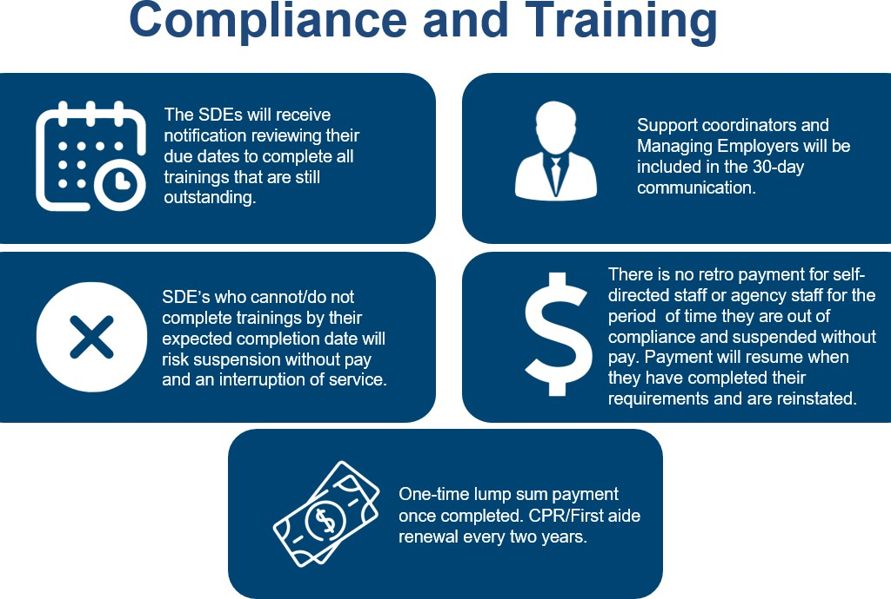

Compliance and Training
In person-practicum available at various site locations

Instructions for completing CPR/FA:
We are utilizing a blended learning training with two parts to complete,
Online & in-person skills.

- Call 800-471-3086 to schedule your in-person skills session.

- Seven days prior to your skills session, you will receive a link
from rclcsfdevteam@redcross.org with instructions to complete the online
training.
  - Please ensure to check your junk & spam inbox.
  - Prepare to allocate 2.5 hours to complete the online training.

- Once you have completed the online portion of CPR/FA, you may proceed with your scheduled in-person training.

If you have any questions, please reply to this e-mail or contact customer service at awccustomerservice@nj.easterseals.com or 800-471-3086.


Benefits of AWC Electronic Platforms
Updates
- AwC is now sending email, voice, and text
message alerts regarding timesheet submission.
- Each month, AwC will host webinars covering various topics to help you with timesheet questions, general inquiries, and much more.

For ME’s
- View, Edit Timesheets- PACE
- Sign off and Approve Timesheets- PACE
- View and complete documentation attestation- Credible Participant Portal
- Complete ME Enrollment packet- Credible Participant Portal

For SDE’s
- Allow you to electronically input your timesheet- PACE
- Access and complete your training forms- College of Direct Supports
(CDS)
- Enrollment and onboarding form- Credible Participant Portal
- Access and complete your state mandated forms through our website link- 321 forms

For Vendors- Via attachments
- View billing and payments- Credible Participant Portal
- See if a payment was processed- Credible Participant Portal
- Know who and what the payment is for- Credible Participant Portal

New Jersey Department of Human Services
Division of Developmental Disabilities

Agency with Choice (AWC) Per-Member, Per Month (PMPM) Cost Table

Per Member Per Month
There is a monthly administrative fee to participate in the AwC model—called the Per Member, Per Month (PMPM) fee.
DDD pays the same amount toward the AwC PMPM fee as it pays for the Fiscal/Employer Agent model The individual budget funds the remainder of the PMPM fee

MONTHLY Cost to Individual Budget*:
ANNUAL Cost to Individual Budget*:

*Include state allowance toward cost
PMPM 1 | PMPM 2 | PMPM 3 | PMPM 4
One or more SDEs working 0-40 hrs. per week for the participant or the employer of record and NOT electing health benefits | One SDE working less than 30 hrs. per week for the participant but 30+hrs. per week for the employer of record AND electing health benefits | One SDE working less than 30+ hrs. per week for the participant AND electing health benefits;-OR-  Two or more SDEs working less than 30 hrs. per week for the participant but 30+ hrs per week for the employer of record AND electing health benefits | Two or more SDEs working 30+ hrs. per week for the participant AND electing health benefits
$193.97 | $340.15 | $442.48 | $736,19
$2,327.64 | $4,081.80 | $5,309.76 | $8,834.28

PLEASE NOTE: Support Coordinators will need to work with the Agency with Choice Fiscal Intermediary directly to determine which PMPM will be applied.


•
Link to instructional video:
https://www.youtube.com/watch?v=GVXcgJxRV30&feat
ure=yo utu.be

Timesheet Process
When completing your timesheet there is a case note requirement for Medicaid billing.

Timesheets Due every Saturday by 11:59pm

No late payrolls or exceptions - all timesheets received after the deadline will be processed during the next payroll cycle.

For individuals signing on as both the ME and SDE – A back up authorizer must be designated to sign off on timesheets

  - As a provider of Financial Management Services, Agency with Choice must ensure that all claims are submitted within Medicaid’s timely filing limits. In order to properly meet that requirement, effective June 1 , 2024, going forward Agency with Choice will be implementing a deadline for timesheets and required documentation to be submitted no later than 300 days from the date a service has been provided.

  - Example: An SDE provided Individual Supports on May 17, 2024. SDE’s timesheet and required documentation must be submitted to Agency with Choice by March 13, 2025.

  - Please note* When timesheets are submitted outside of the original pay period, it increases the risk for discrepancies to be present, which may cause delays in payments and claim submission. Therefore, it is imperative that timesheets be submitted as soon as possible and no later than 300 days from the date a service has been provided.



Vendor Enrollment

  - Agency with Choice does NOT approve or deny vendors

  - We will enroll the vendor that is in the approved
plan of care

  - If there is a question on which type of vendor services are allowed, it is best to contact SC

  - Once AwC receives the authorization from the approved plan of care we will begin outreach to the vendor to start the enrollment process

  - A consumer must have one SDE with Agency with Choice to be eligible for AwC to pay community vendors


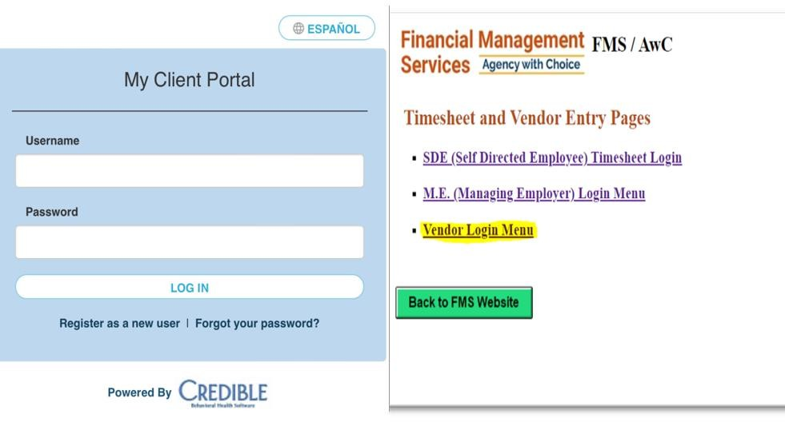
Vendor Enrollment (cont.

    - Vendors are sent through adobe sign:
      - W-9
      - Electronic Funds Transfer Letter (EFT)
      - Vendor Request Form
      - Certificate of Liability Insurance (COI)
      - Support Manual service description/ expectations

    - Once enrollment is complete the Vendor is sent a voucher or given access to our AwC Pace website to submit for services rendered along with instructions

    - AwC Client Portal- EFT payments
    - AwC Pace website

    - UPDATE: Vendor webinar, coming soon!


FMS Website

Our website supports DDD program participants under the Supports program and the Community Care Program or CCP, Managing Employers, Self-Directed Employees, Support Coordinators, Community Vendors and Support Brokers.

You can find all forms and resources located on our website visit.

http://www.financialmanagementservices.org/
FAQ’s and Content
Spanish/English translated content

Direct Link to our electronic payroll system and documentation portal.
Goods and Service List: Approved vendors and contact information.

Contacts You Need to Know

AwC Time Sheet Submission Email awcforms@nj.easterseals.com

AwC Time Sheet Submission
Fax 1+888-399-0427

AwC Customer Service Phone
Number 1+800-471-3086
AwC CSR Email
awccustomerservice@nj.easterseals.com
AwC Escalations
AWCADMIN@nj.Easterseals.com

Training and Compliance
Awccompliance@nj.easterseals.com

awchr@nj.easterseals.com awcenrollment@nj.easterseals.com awcpurchasing@nj.easterseals.com



THANK YOU

