Blended Learning Instructions For CPR/AED/First Aid

This document provides detailed instructions for completing your CPR/AED/First Aid certification. It’s important
that you follow the steps below to avoid delays in your certification or re-certification.

STEP I – COMPLETE THE RED CROSS COURSE ONLINE
- Red Cross provides an interactive online training through their site (link below).
- First-time users must create a log-in. You can use either your personal or your Easterseals email address. For recertifications, the system allows you to reset your password if you forget your credentials.
- Please allow approximately 2- 2 ½ hours to complete the course.
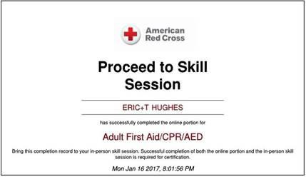
- Upon completion, you should either print the certificate or have available on your cell phone. The certificate must be presented to the Trainers prior to the in-person session.

This certificate must be submitted to training@nj.easterseals.com with the subject heading "BLENDED LEARNING CERTIFICATE" no later than 24 hours prior to the classroom

To access the Red Cross online training go to: https://www.redcrosslearning.com/course/02b6b8e0-c611-11e6-81f6- a5a76b229f34

IMPORTANT INFORMATION FOR YOUR ONLINE SESSION
- You MUST use either Chrome, Firefox or Microsoft Edge as your browser for this training.

(Internet Explorer is no longer compatible)
- You may leave the training session ONLY in between "missions" (the term used in this training for modules). To return to the training use the same link above and use the login credentials you created.
- If you exit in the middle of a mission, your work will not be saved.
- If you fail a mission, you will be able to redo it until you pass it.

STEP II – IN-PERSON CLASSROOM SKILLS PORTION
Please contact the Agency with Choice customer service team to schedule your In Person classroom training. Their contact information is: awccustomerservice@nj.easterseals.com or call 1-800-471-3086.

- During this session, you will be asked to demonstrate the skills you’ve learned during the online portion.
- This should take approximately one (1) hour of classroom time.
- Within 24-48 hours of your classroom session, you will receive a link via email from the Red Cross, to obtain your OFFICIAL certificate. (a wallet card can be also be printed or requested via the Red Cross site (www.redcross.org)
- The Easterseals trainer will send your certification of completion to training@nj.easterseals.com for confirmation.

**PLEASE READ** - IMPORTANT CERTIFICATION INFORMATION
- To be certified in CPR/FA, you must pass both Step I and Step II.
- If you are unable to attend the in-person session, please email training@nj.easterseals.com
- If you are not certified by your CPR/First Aid expiration date, you will be suspended until you achieve certification and may face additional disciplinary action.
- You MUST complete Step I before you are eligible to complete Step II. If you have not presented the online certificate of completion, you WILL NOT be unable to continue with the classroom training.

