The majority of the sessions are held at the Administrative Support office located at 241 Forsgate Drive, Suite 200, Jamesburg, NJ 08831 (2nd Floor).

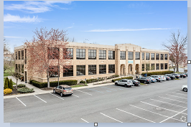

To enroll in a session, email [AwCcustomerservice@nj.easterseals.com](mailto:AwCcustomerservice@nj.easterseals.com) with your name and contact number. Due to COVID-19, Agency with Choice has taken additional measures to ensure the safety of the staff and training participants.

After enrolling in a class with our customer service team, you will be sent email instructions to complete the online portion of the CPR and First Aid course offered by the American Red Cross Association.

The training participants will still be required to attend the in-person skills component to receive their certificate. The receipt of completion of the online portion must be brought with the training participant on the date of their in-person skills component. The training participant will receive their timeslot for the in-person component for the designated training date they selected when enrolling in the course.

The following are the additional measures Agency with Choice is taking:

* Masks are optional and available at the training.
* Gloves and face shields are provided during training.
* All CPR mannequins and equipment are disinfected and sanitized before & after each training.
* The entire room is disinfected after use and again prior to training.

If you have any additional questions, please contact one of our customer service representatives at our toll-free number 1-800-471-3086 or at [AwCcustomerservice@nj.easterseals.com](mailto:AwCcustomerservice@nj.easterseals.com).