Timesheet Completion and Submission
Step Action Guide

Exciting things are happening at Agency with Choice!

Financial Management Services Fiscal Intermediary Agency with Choice (AWC) has developed a streamlined approach in serving our consumers while delivering the most efficient service with the same core values of warmth, expertise, and respectfulness that our consumers and families have come to expect from Agency with Choice over the years!

In an effort to identify new and efficient methods within organizational operations, we appreciate your cooperation as we implement a newly designed process. Our goal is to provide a simplified approach to how service documentation and payroll timesheets are submitted to benefit both staff and consumers!

Important changes to timesheets - a mandatory fee-for-service billing component has been added. It will require a 2-page timesheet submission as mandated by Medicaid and the state of NJ. Since this is a new payroll process, we strongly recommend that you read the following information carefully to fully understand the important changes in the new timesheet submission process. Please note that you are now required to submit payroll timesheets WEEKLY.

Enclosed you will find:

- Timesheet Completion and Submission Step Action Guide
- Timesheet Completion and Submission Policies and Procedures
- New weekly Payroll schedule
- Holiday Schedule
- Self-Directed Employee (SDE) / Managing Employer Signature Form

This guide is designed to instruct the SDE in completing the timesheet. The Managing Employer is still required to review and approve the 2-page timesheet, so please review all this information with your staff and pay special attention to sections in green that apply to the individual consumer receiving services as identified in you Plan of Care (POC). The forms have been created and updated to reflect the hours authorized in your POC. There is an Outcome/Service attached to each authorization.

To Complete Page 1 of Timesheet

Important Note:
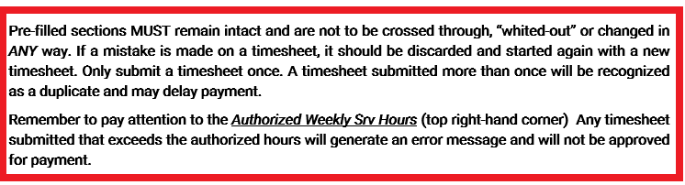
Step 1: Be sure to stay within the dates approved in the plan of care. Fill in the appropriate box (Month/Day/Year) for date worked. For a valid entry, print clearly and within each box. You must have 2-digit entries: ex: 06/01/19 with 0 (zero) in front of one-digit numbers. Only “standard time” will be recognized (no military time) for the “In and Out” section.
- Fill in the date of your shift
- Then, directly across the same line: Fill in the time in/time out
- Enter the hours for that shift (Under the appropriate column for that Outcome/Service Hrs.).
*If you work with more than one consumer – Remember to verify the time recorded is specific to the consumer on the pre-filled time sheet *
*If there are 2 Outcome/Services listed on your timesheet, make sure you are submitting the hours worked on that service in the correct Outcome Service column. If there are more than 2 Outcome/Services in your plan, you will get an additional timesheet for Outcome 3 or more.
Example:
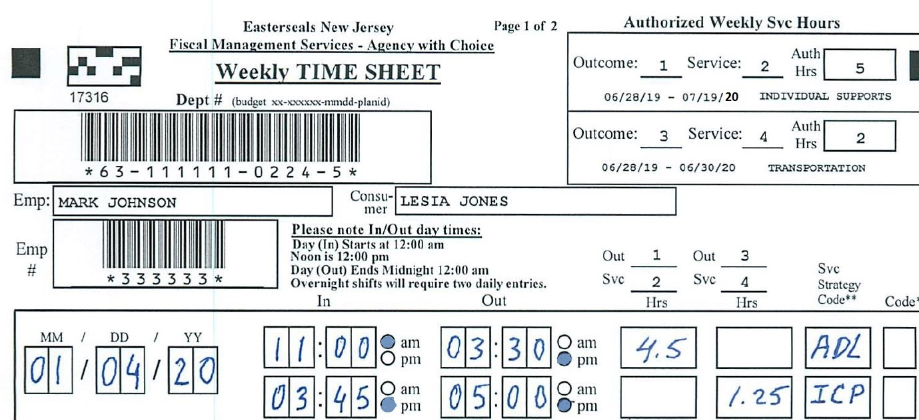
Write clearly and within the boxes

Step 2: ** Service Strategy Code - (Located on the Bottom Left of paper timesheet)
See examples below and the codes for each activity to be used in that column.

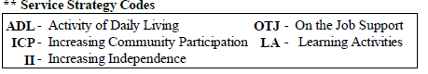
- (Code ADL) Assistance with Activities of Daily Living (such as getting dressed, eating, personal hygiene, etc.)
- (Code ICP) Assistance with Increasing Community Participation (such as daily errands, attending events, going to a restaurant, purchasing items, travel training, etc.)
- (Code II) Assistance with Increasing Independence (such as helping the individual learn to do laundry, cook, clean, dress, grocery shop, pay for items, etc.)
- (Code OTJ) Assistance with On-The-Job Support (such as safety awareness, using the restroom, attending to task, lunch/breaks, etc.)
- (Code LA) Assistance with Learning Activities (such as tutoring- math, reading, etc.; or support in attending a class)

Step 3: Time off Code (If Applicable- Located on the bottom right of paper timesheet)
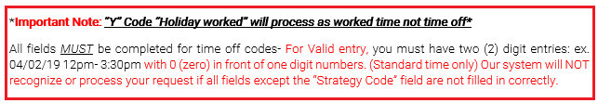

P - PTO (Paid Time Off) i.e., Vacation, Flex Time, Sick days, Personal days
B - Bereavement (Accepted only if direct relation to the deceased; need an official funeral notification)
H - Holiday (Paid holidays as per SDEs (Self Directed Employees) benefits)
J - Jury Duty (need a note from the court confirming attendance that day)
Y - Holiday worked (on an approved holiday)
F - Floating Holiday (scheduled day off – 2 per year available to Full time staff only)

Step 4: Total Hours:
Add up the total hours per row (Outcome/Service) and enter Total Hrs. Srv. box.
Hours should be reported in ¼ hour increments only:
Example: 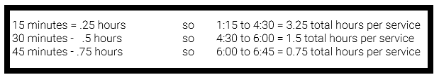

Step 5: SDE Signature and Date – acknowledging the hours reported on the paper timesheet are complete and accurate
Individual/Managing Employer Signature and Date - acknowledging they received the hours and services for each Outcome/Service as reported above.
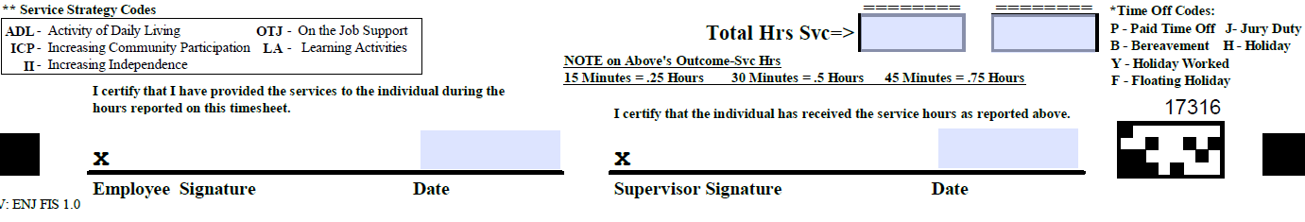

To complete page 2 of Timesheet
This is the NOTE page which outlines the service that was delivered to the individual

Step 6: Location Codes/ Place of Service Codes (Located on the Second page of the Timesheet)
- Location codes are used for billing purposes.
- They will become a required field on the timesheet.
- Any services provided with an E-EVV location code must also be documented in HHAeXchange.
- 1 of the 5 Location Codes must be entered on the timesheet for each shift that is worked.
*Place of service codes will be a mandatory field on all timesheets starting January 1st, 2022. *

Location Codes:
L-live-in
V-virtual
C-community
P-place of employment
E-EVV

Step 7: Be sure to stay within the dates approved in your plan. Fill in the appropriate box (Month/Day/Year) for date worked. For a valid entry, you must have 2-digit entries: ex: 06/01/19 with 0 (zero) in front of single digit numbers. This field Must be identical to the information recorded on page 1 of the paper timesheet.

- I.A. – Individualized Activity (what did you do?)
State the action of the SDE that directly applies to the Outcome/Strategy responsibilities to the individual, outlined in the plan of care. (Ex: Took Jane to the grocery store). This should be a phrase or short sentence describing the service delivered.

Example Highlighted:
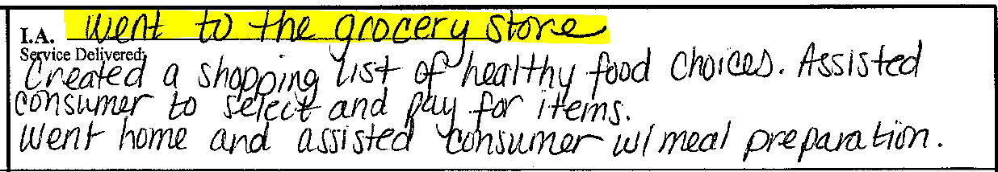

- Service Delivered (how did your activity directly help the individual) – Corresponding Note documentation.
Example Highlighted:
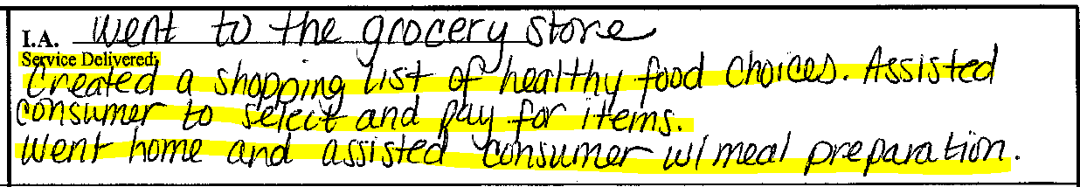

Explain how your Individualized Activity contributes to the outcome and strategy as defined in the consumer plan of care. How the SDE assists the consumer to achieve their goal within the program.

(Ex: Created a shopping list of health food choices. Assisted consumer to select and pay for items. Went home and assisted consumer with meal preparation). Notes should be clear, concise, and relate directly to the goal presented in the plan.

Notes are written to meet Medicaid compliance for billing. As a caregiver, you are here to assist the consumer achieve their goals; therefore, you must record how you supported the consumer during each shift. Included are some examples of billable vs non billable notes. Goals are provided by the Support Coordinators and the State, based on consumer necessity.
Example 1

Consumer Outcome

Jane will pursue employment

Billable Note:

Today I met with Jane about her goal to pursue employment. To achieve her goal, we talked about working and the steps she needs to take to be able to apply for jobs. I will continue to work with Jane on this goal.

Non- Billable Note:

Today I met with Jane, helped tidy up around the house and fed her.

Example 2

Consumer Outcome:

Jane will strive to become independent at home and in the community.

Billable Note:

Jane was not feeling well when I arrived, so we discussed what she wanted for dinner, and she helped me gather the ingredients before she went to lay down. Jane came out and set the table and ate most of her meal. We watched TV together instead of going for a walk so she could rest.

Non- Billable Note:

Jane was not feeling well.

Step 8: SDE Signature and Date – acknowledging the services to the individual, as reported on the paper timesheet are complete and accurate. (Page 2)
Individual/Managing Employer Signature and Date acknowledging they received the services for each Outcome/Service as described above.

Fax the completed two-page timesheet to 888-399-0427
or
email to awcforms@nj.easterseals.com

by 11:59pm Saturday (weekly)

When faxing or scanning timesheets and documentation page

DO’s | DONT’s
Capture the full page to include the prefilled barcodes. Make sure page is faxed in straight. | Taking pictures of the timesheet via cell phone or electronic device is prohibited
Submit all timesheets via email as an attachment. The “paperclip” icon will allow you to attach the timesheet | Do not copy and paste in the body of the email. Timesheets that are embedded in an email are prohibited.
Retain copy of timesheet until a paycheck has been received for that time period with no discrepancies | Do not send multiple copies of the same timesheet. Wait until it's processed and resend only if requested by the Agency with Choice staff.
Check that both pages (timesheet and note page) are being sent in and both have been signed | Timesheet (page 1) must be sent with the note (page 2). Don’t send these pages separately
Make sure to write in the correct column for each outcome/service on timesheet and note page | Dates of service are very important, don’t forget to write the date/time for each shift on both pages
Pay attention to the weekly authorized hours on the upper right corner of your timesheet. You will only be paid up to those hours listed. | Do not submit time worked over the approved authorized hours. Overtime is not allowed and will not be processed.
Pay attention to the instructions for documenting each activity and service delivered, if your note is not accepted, it will delay payroll processing. | Make sure each shift submitted has a corresponding and acceptable documented activity on Page 2 (the note page)

